## NOTHING BURNS LIKE PATRIOTISM

-DEEPAK VERMA

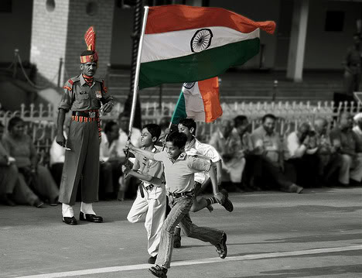

Gone are the days when people used to feel the fire of patriotism in their hearts. Gone are the days when great revolutionaries dared to sacrifice their lives. Bhagat Singh and Mahatma Gandhi have become an anachronism today. The love and affection towards one’s nation has taken a back seat. A possible reason of such a situation where patriotism cannot be seen around is the unpatriotic government officials who are selfishly enjoying their position which they got from the sacrifice of our national heroes. Our freedom fighters sacrificed their lives to clean up the British regime, restored the whole system with a new hope of independence and this is that very system which is full of corruption, allegations, selfish officials and lawmakers who aren’t patriotic at all. Literally, it is true that nothing burns like patriotism. Rather, real patriotism was burnt the day when selfish and corrupt feelings arose in those very people who run this country.

Today, even after 66 years of independence, our country is still facing the problems of poverty, unemployment and various such issues. The question is- why have the policies of our government failed to curb these problems? Where the hell do the funds assigned to such policies go? Why is our so called patriotic government which is said to be elected from the people & by the people, not able to deliver what it takes to be a united and prospering country? The only answer is lack of patriotism, lack of love for the country, lack of love for the country’s people and the highly prevailing selfish & greedy interests of our lawmakers.

Even the common man has lost interest in this nation. People like me and you are so much fed up of this system that we want to flee away from this system. Had the government been patriotic and provided the nation with the growth and development which we need today, had the government not been selfish and catered to the needs of the nation instead of feeding their own bellies, this nation would have been a superpower in the world and a much better place to live in. Today, how many of us celebrate the Independence Day with a feeling of patriotism? I think it’s rather the joy of break that we get from our working schedule on a national holiday. And the joy totally vanishes if the Independence Day lies on Sunday. Patriotism is evidently not burning in our hearts. We are busy and self- centred people who care least about the nation.

Let me give you another example. Hosting International games such as Olympics, Commonwealth Games etc. provides an opportunity to the nationals to identify with and take pride in their nation’s development. In 2008, when China hosted Olympics, they were swept by a wave of patriotism and headline-grabbing scams and scandals were not there to dampen the mood which is altogether contrary to India’s recent Commonwealth Games.

Though the feeling of patriotism has faded, but, I would say, the concept of patriotism is still there. I will tell you how. Take Ramdev Baba. He has commercialised patriotism and is encashing it for materialistic gains. “Swadeshi apnao, videshi bhagao” strategy of Ramdev’s Patanjali trust exemplifies how he is making money by selling indigenous products in the name of patriotism.

India is eagerly waiting for the day when a staunch leader would take charge of this nation, the day when cheap and nasty politics would subside to its minimum level, the day when India would begin to prosper.

